LANDSCAPING TIPS brought to you by the Arizona Landscape Contractors’ Association. www.ALCA.org

We are now in the thick of winter. Since many of our landscape plants are considered tropical or sub-tropical, we begin seeing frost damage on plants, like Lantana, when temperature hit the low 30’s, while other plant don’t show damage until temperatures have been below freezing for a number of hours.
Frost blankets seem to be the favorite choice in our region, providing up to 8-9 degrees of protection. However, they are often used incorrectly. Here are a few helpful hints to make sure you are using protective frost blankets correctly:
- Use cloth or paper, never use plastic!
  - Sheets or blankets, must be removed daily
  - Frost cloth can be left on for a few days
- Drape plant from top all the way to the ground
- Do not allow any openings (trap heat rising from ground under cloth)
- Do not gather the drape around trunk
- Allow drape to cover all the way out to drip line, if possible
- Wrap trunks of young citrus trees loosely to the ground (can be left all winter)
Additional steps to help protect your plants from the cold:
- Lights, Christmas lights at bottom of plant can radiate heat
- Water under canopy adds heat: when water cools, energy is released=heat!
- Don’t Fertilize- new growth is more sensitive to frost damage
- Don’t Prune- don’t prune sensitive plants until after treat of frost (late Feb.)
- Don’t Overprotect- allow plants to harden off, gradually exposed to cold weather

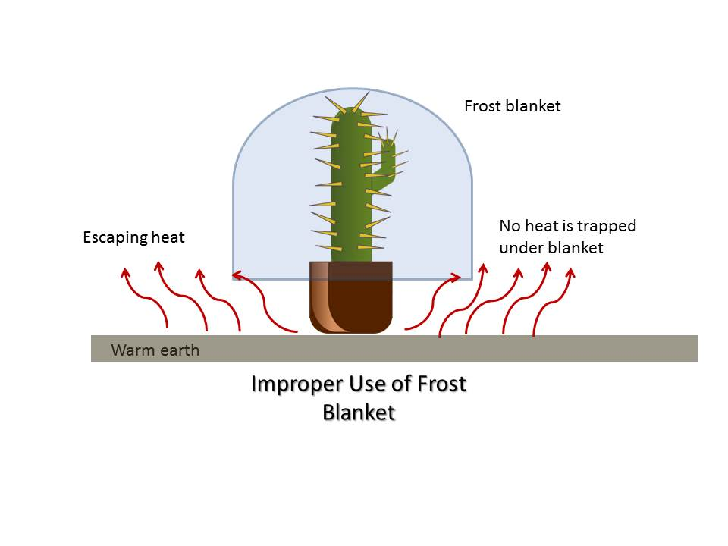
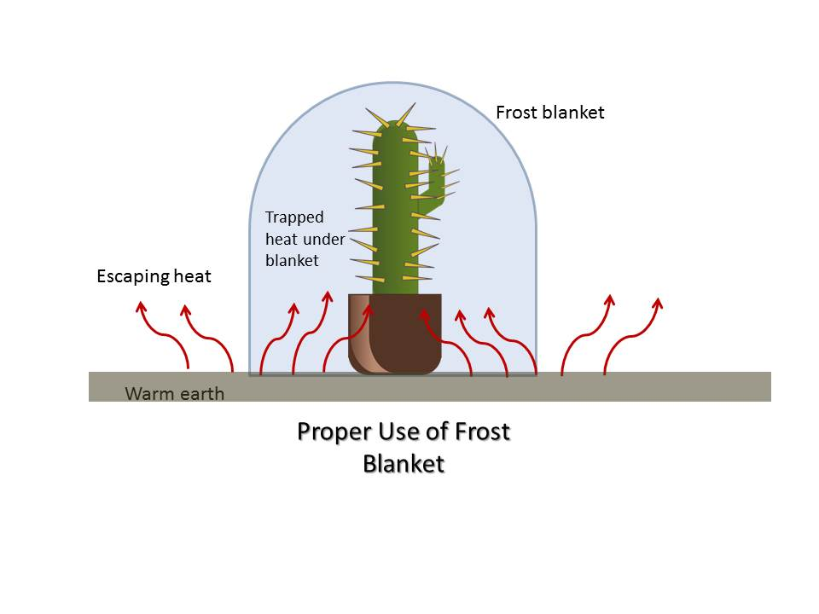
PROTECT YOUR INVESTMENT! HIRE AN ALCA MEMBER

